DatabaseFoundations

Workshop #1

DesignDatabaseYoutube

Alejandro gomez moyano

1.user stories:

I want to comment in this video

This chanell have a lot of videos

This video is for kids

I create this play list for each genre of my favorite music

First step: foundtheentityofthisplatform :

1.chanels

2.usersorsubscribers

3.videos

4.comments

5.playlists

6.type_of_chanell

7.type of video

8.topic

Second step: define atributes per entity

1. Id, name,email ,type,videos ,subscribers
2. Id,name ,email,comments ,playlist
3. Id,name, duración,type ,topic,type,views,likes ,dislikes,comments
4. 4.Id,description,users,likes,dislikes
5. Id,name ,descriptions,user,videos
6. Id,name
7. Id,name
8. id,name

Thrid step:

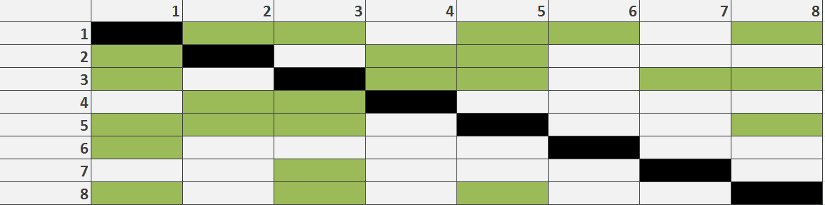

Foursteps: define relationsshipstypes

chanell no mandatory many to no mandatory many users

chanell Mandatory one to no mandatory many videos

chanell Mandatory one to no mandatory many playlist

chanell mandatory one to one mandatory type of cannel

chanell Mandatory one to no mandatory many topic

users mandatory one to one mandatory comments

users mandatory one to no mandatory many playlist

videos mandatory oneto no mandatory many comments

videos mandatory one to mandatory one type of video

videos mandatoryoneto no mandatorymany topics

videos mandatoryoneto no mandatorymany playlist

play list mandatory one to no mandatory many of video

play list mandatory on to no mandatory many of type of video

Five step: first MER draw

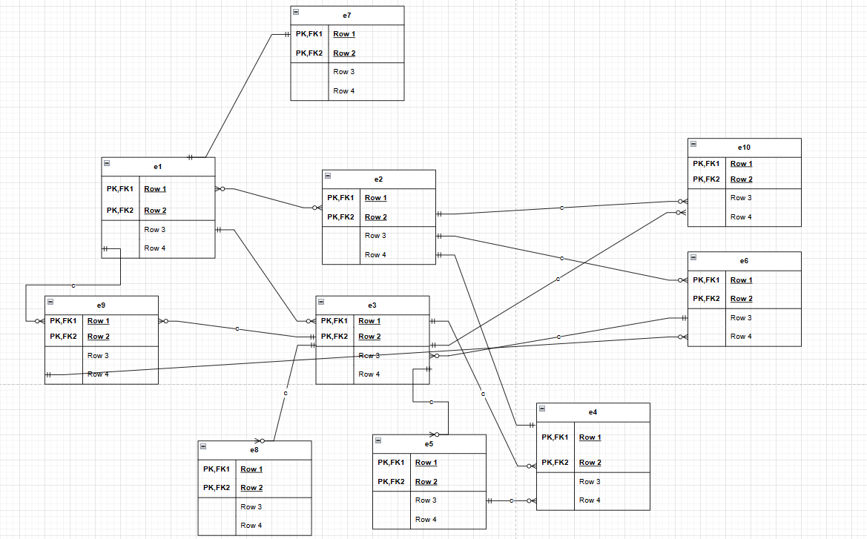

Sixstep :first Split manytomany

E1 chanel -> FK e7 typeofchannel

E1-e2 break

E1 chanell->FK e3 videos

E2user->FK e6playlist

E2 e4? break

E3 videos->FK e5comments

E3 videos ->FK e5 comments

e6 playlist - > FK e3 videos

step number seven: break relation many to many

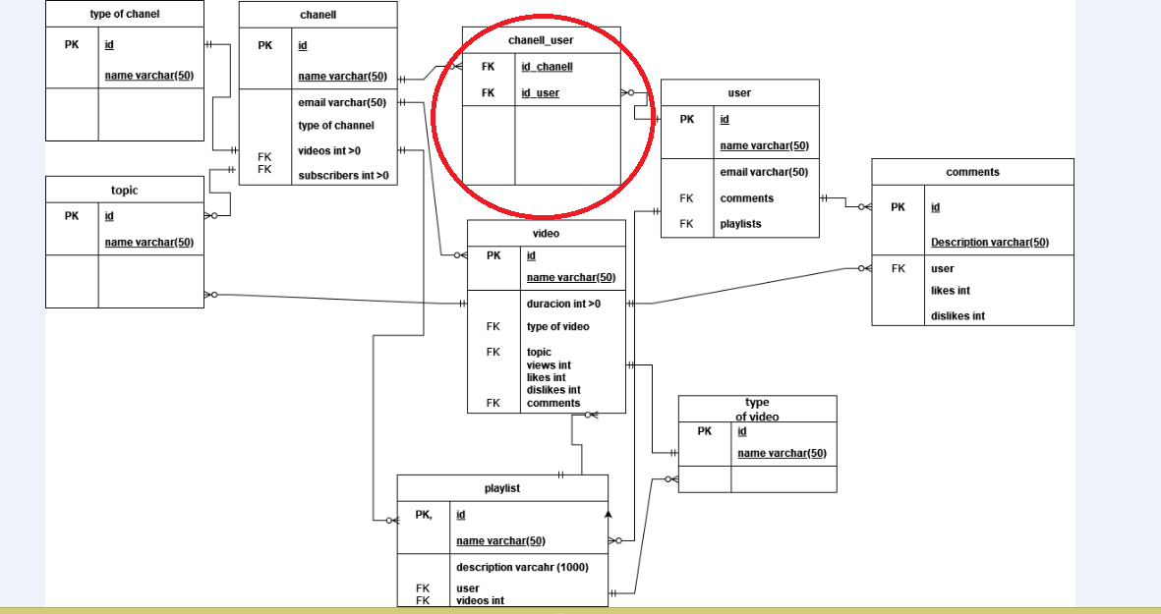

Step number eight: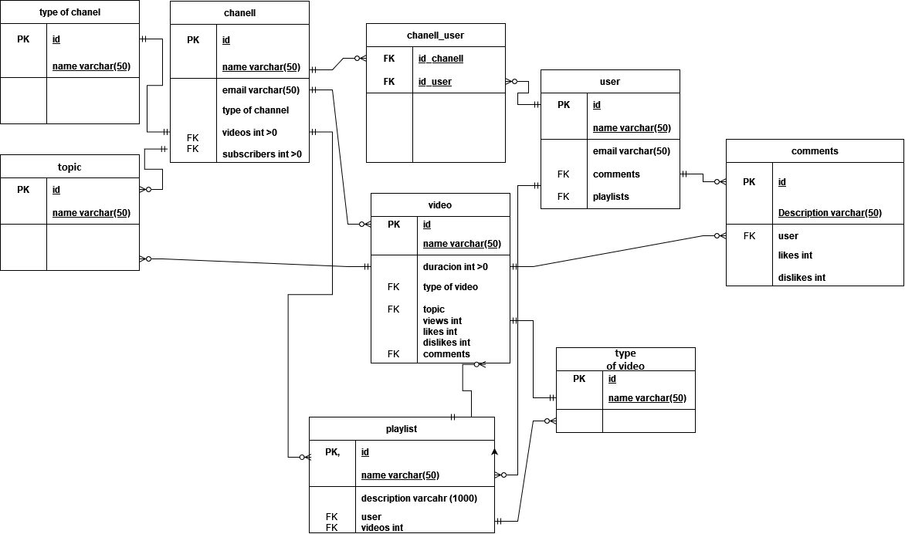

Step number nine : give atributes

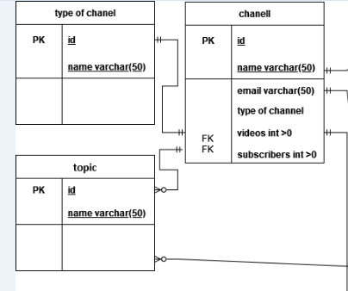

3. was dificult found the identitys but with the means of verbs i can make it

4. with draw.io was dificult to use the relation because there are a lot of